**Name: Victoria Jacqueline Macías Pico.**

**W O R K S H E E T S**

**NOTE:** **Your answers must be in blue and bold.**

# UNIT 3



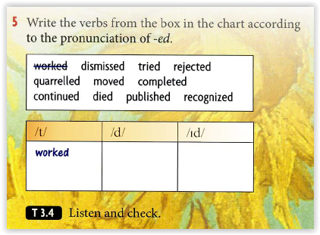

**Tried**

**Recognized**

**Quarreled**

**Moved**

**Continued**

**Rejected**

**Completed**

**Died**

**Dismissed**

**Published**

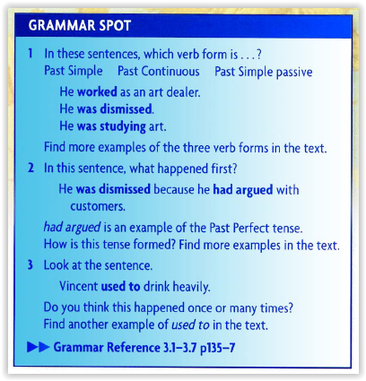

**used do**

**1. Complete the sentences below with used to:**

1. What music  **did you use**  to like when you were a child?
2. I  **used to** listen to music when I was a child.
3. We  **used to go**  to the cinema at weekends.
4. They  **used to live**  in the country, but now they live in the city.

**BONUS:** I  **loved**  the cake you made me last week.

**Practice:** <https://www.perfect-english-grammar.com/used-to-exercise-1.html>

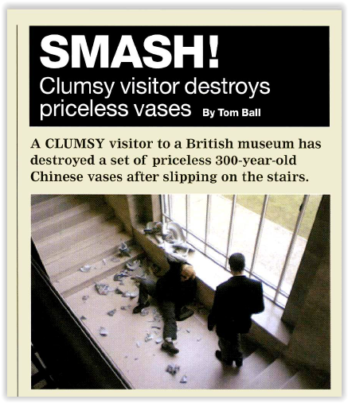

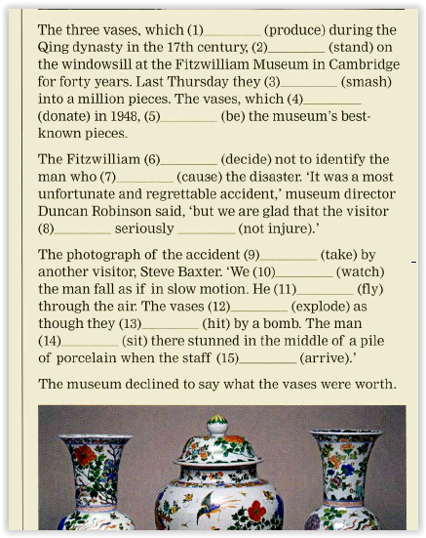

**Were produced**

**Had stood**

**Were smashed**

**Had been donate**

**Decide**

**Had caused**

**Wasen’t**

**Injured**

**Injured**

**Was taken**

**Watched**

**Was flying**

**explored**

**Had been it**

**Was sitting**

**arrived**

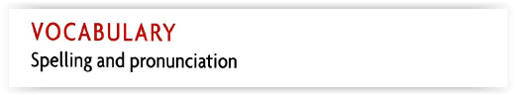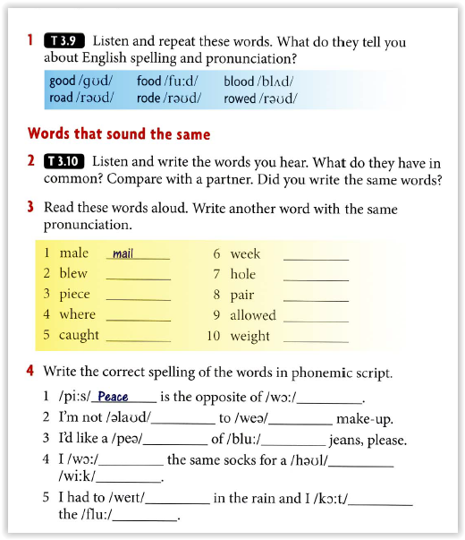

**Blue**

**Peace**

**Wear**

**court**

**Weak**

**Whole**

**Pear**

**Aloud**

**wait**

**war**

**allowed**

**wear**

**pair**

**blue**

**wore**

**whole**

**caught**

**flu**

**wait**

**week**

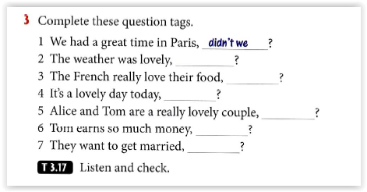

**Wasn’t it**

**Don’t they**

**Isn’t it**

**Aren’t they**

**Doesn’t He**

**Don’t they**

**QUESTION TAGS:**